Mobile Applications Development 2

– Project Design Document

Name: Colin Roche
Student ID: G00349215

Idea
The application I will be making for my Mobile Applications Project will be a recipe-based app. This app will be written using Xamarin and Visual Studio. The app will store recipes on a database and give the user new recipes each day for each one of their meals. This will include a recipe for breakfast, lunch, dinner and desserts.

Design

Home Page
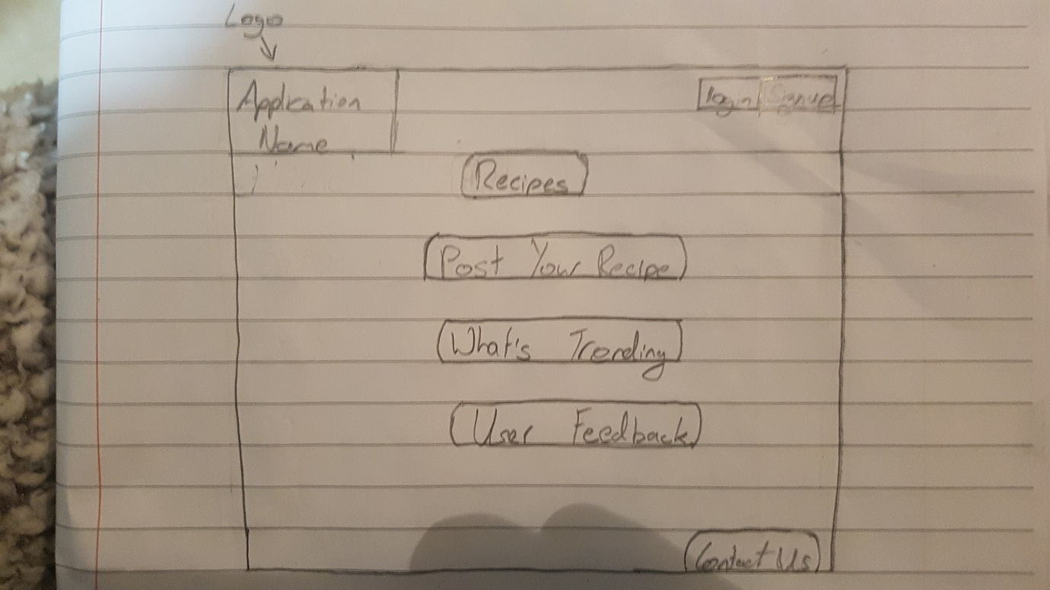

This page allows the user to sign up to the app, go to the recipes, posting, trend and feedback pages. It also allows the user to contact us directly if a problem has arisen.

Recipes Page
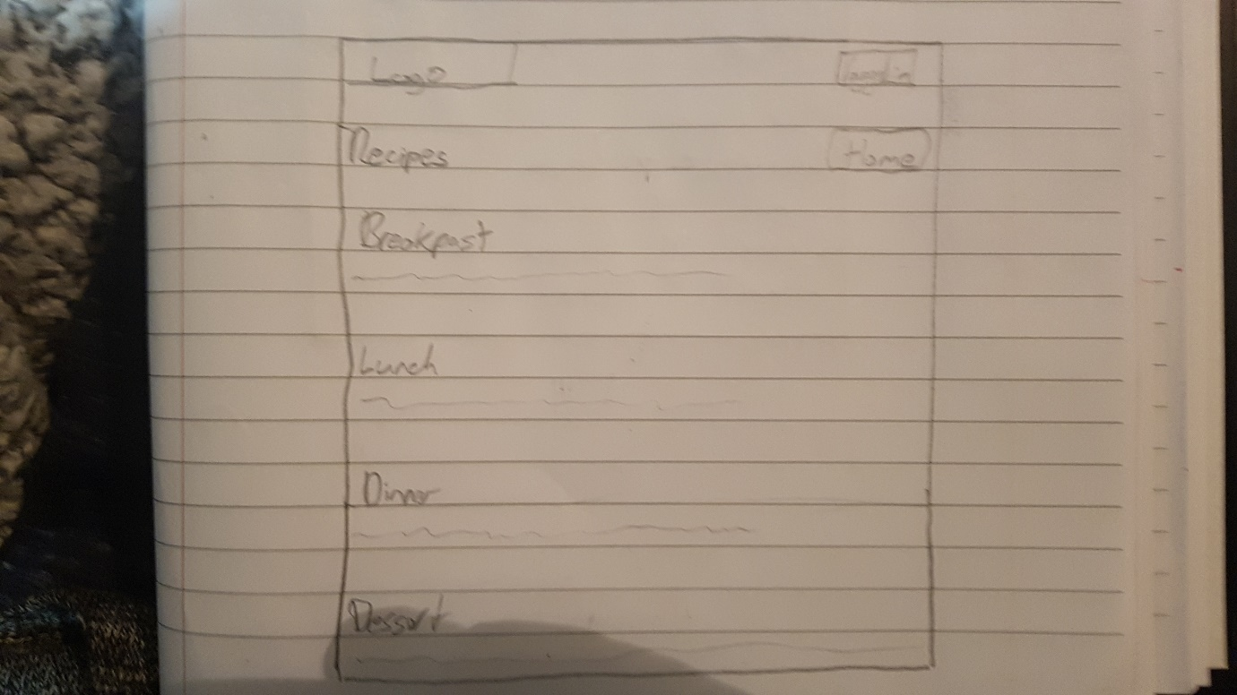

This page will be updated daily, getting recipes from a database. This page will have 3 recipes that you can pick. Each recipe will have the ingredients, cooking instructions and an image so the user knows how it should look.

Post your Own
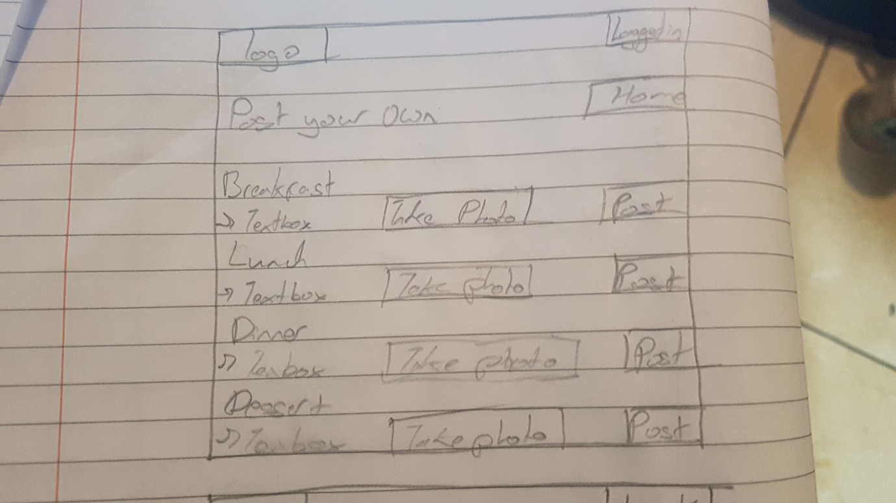

If the user has a particular recipe, they think other people will enjoy they can post it to us from this page. The user just selects which meal it is for, ingredients, cooking instructions and an image of meal. When they post the recipe it will be converted to a JSON format and added to its own database. We will go through and see if the recipe is done to certain standard. If so, we will add it to the collection of recipes that we provide. The user will have to the app access to the camera to do this.

Trending Page
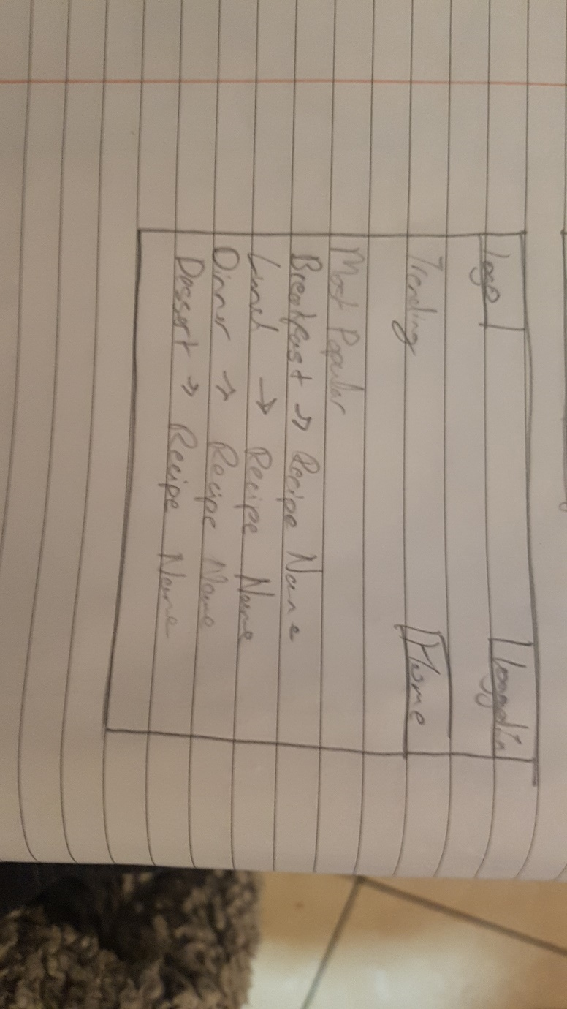

The user will have the option of rating each recipe if they so desire. The most rated and highest rated recipes will appear on the trending page.

Feedback Page
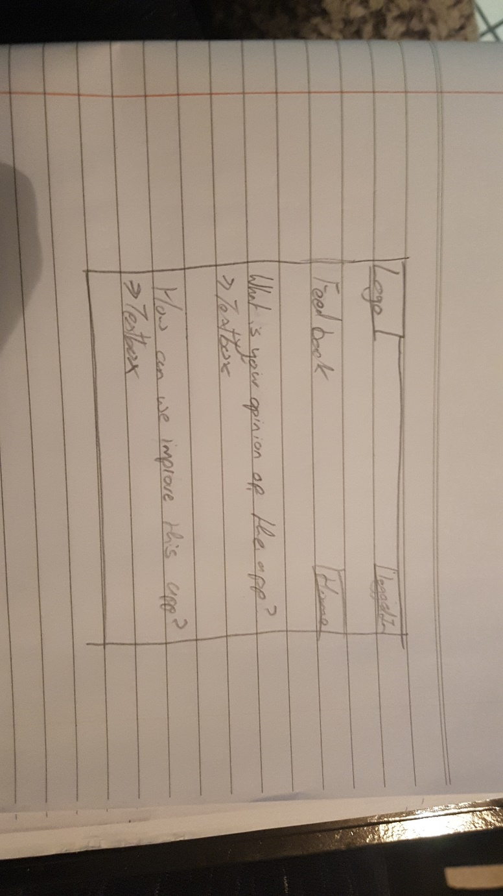

This page is here if the user wants to let us know what they think of the app and how we can improve on this. This feedback will have it’s own dedicated database which will contain the user’s comments and name. This will make it easier for us to make sure each user is satisfied by the app.

Contact Us
This will contain our contact details if the user feels the need. If the user has a problem they feel needs urgent attention they can let us know here.

What could be added?
We hope to use your phones location services to find your nearest restaurants that serve food that are relative to the recipes posted that day.

